Project Week-1

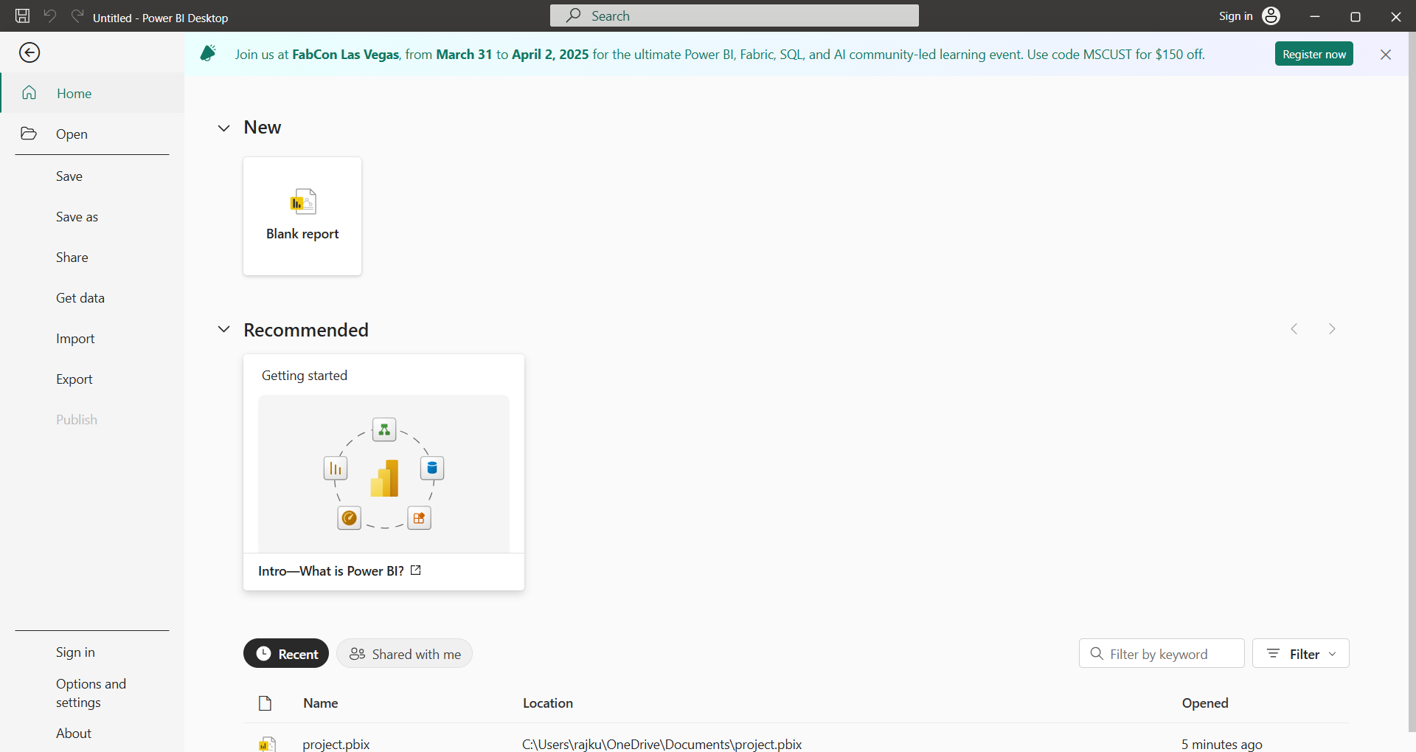

This is the power BI Desktop interface. we will click on the blank report.

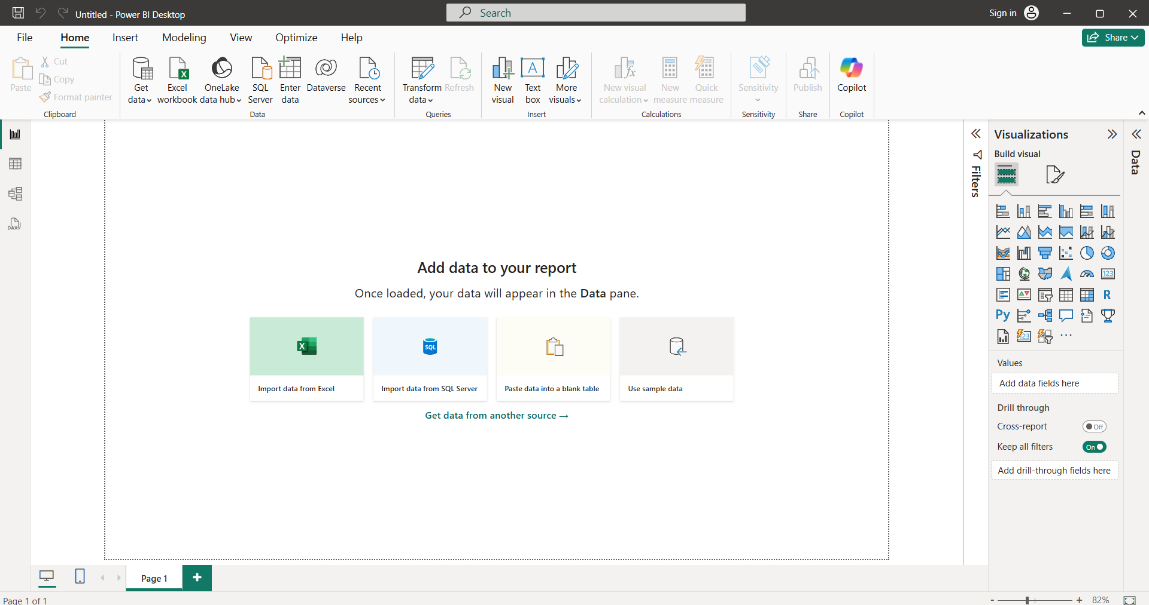

This is the region for import the dataset from various data sources. We will import dataset from Excel, SQL Server, Text/csv and many more etc. Then download Indian agriculture sector dataset then import into power BI Desktop.

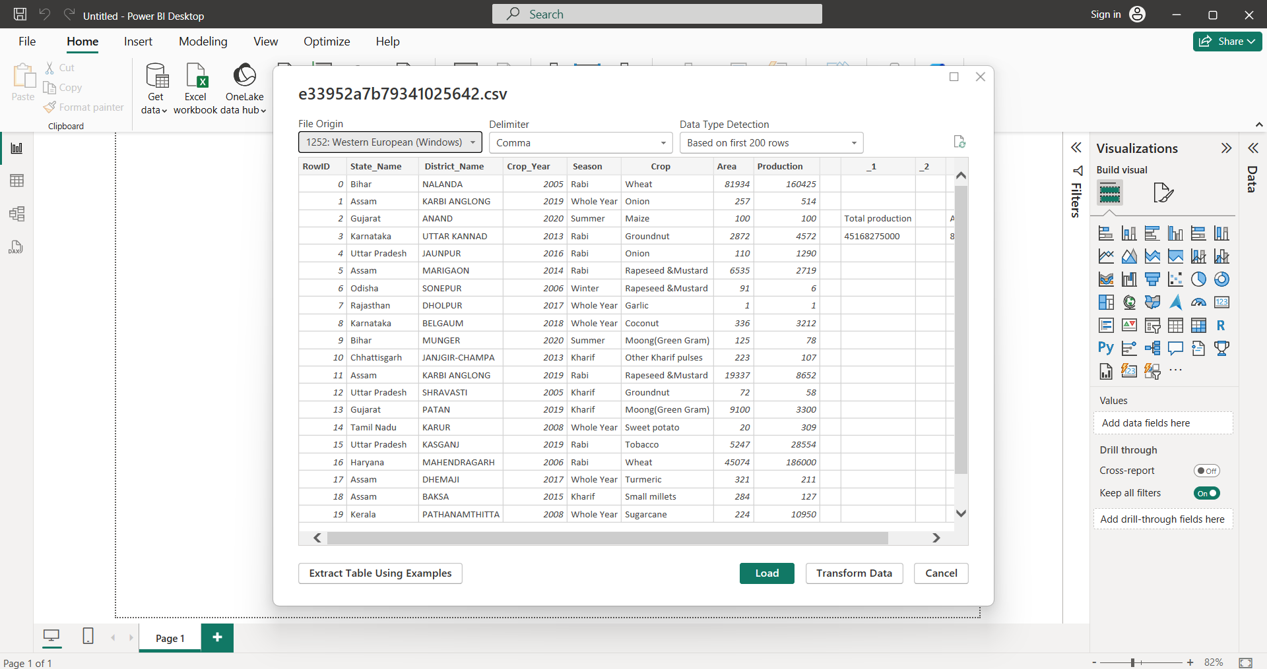

Data will be imported. We use ETL Format stands Extract, Transform and Load. Then load the Dataset when dataset is cleaned.

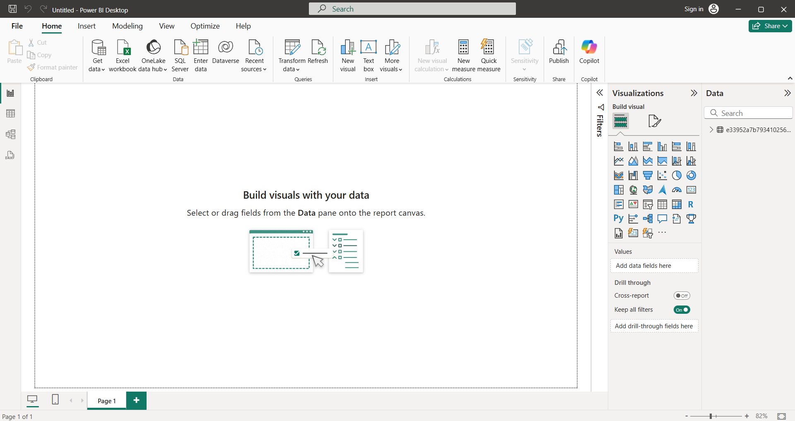

This is the interface after we Load the Dataset. Here three are there

Report view: Visualize the dataset.

Table view: show the table format.

Model view: create relationship among data.

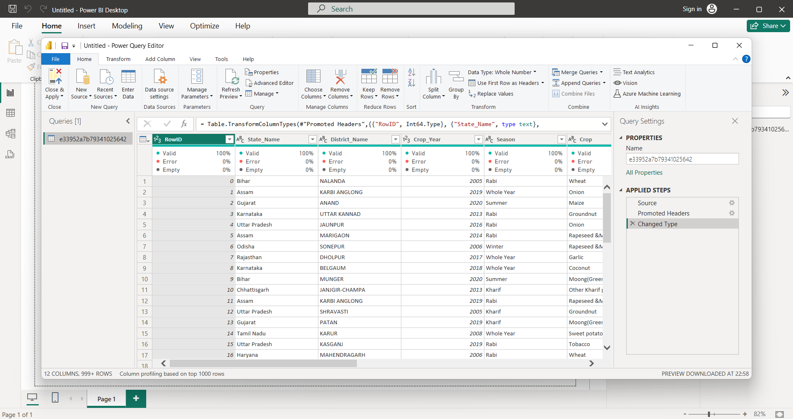

Then transform the data it will takes into power query Editor. Where u will remove the unnecessary rows, columns and null/duplicate values. Then click on left corner close and apply. It changes will applied for power BI Desktop.